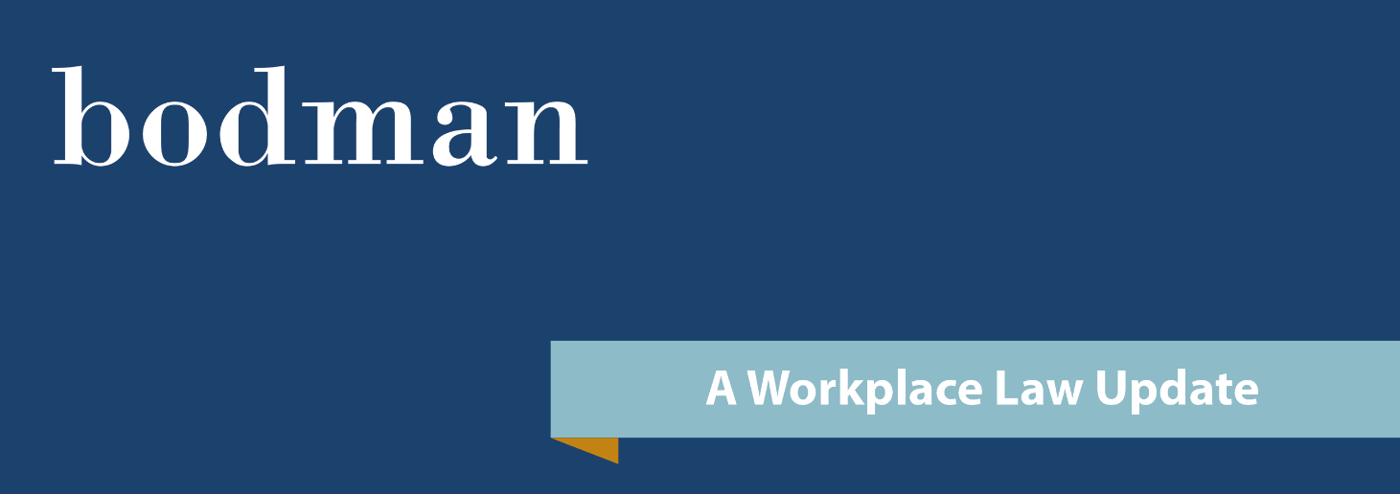

**Bodman PLC August 7, 2025**

**Contractually Shortened Claim Limitation Periods are No Longer Automatically Enforceable Following Supreme Court Ruling**

By: John T. Below, Member, Workplace Law Group

On July 31, 2025, the Michigan Supreme Court changed the test for enforceability of contractually shortened claim limitation periods in *Rayford v American House*.  Employers often shorten the statute of limitations of certain state employment law claims to 180 days or six months in their applications, employment contracts and other on-boarding documents. Employers need to be aware that following the Supreme Court’s ruling in *Rayford*, shortened claim limitation periods are no longer automatically enforceable.

The court ruled that employees and employers can agree to shortened limitation periods (applying to state law claims), but that *special scrutiny* applies when the provision is contained in non-negotiated, boilerplate employment agreements.  The court ruled that such provisions—commonly found in employment applications, handbooks, or acknowledgment forms—are adhesion contracts that must be examined for *reasonableness* before being enforced.

Importantly, the court overruled earlier cases (*Clark v. DaimlerChrysler* and *Timko v. Oakwood Custom Coating*) that permitted six-month contractual limitation clauses in employment agreements without a fact-specific reasonableness analysis. Going forward, Michigan courts will consider the following when determining if the shortened period is reasonable:

1. Whether the term provides the employee sufficient opportunity to investigate and file a claim;
2. Whether the duration is not so short as to effectively eliminate the right of action; and
3. Whether the limitation bars a claim before the harm can reasonably be ascertained.

Agreements with limitation periods will remain subject to traditional contract defenses such as unconscionability, but it will be much easier to attack such agreements under the *Rayford* test.

Though they are no longer automatically enforceable, *Rayford* does not prohibit employers from using shortened claim limitation periods, and employers may wish to continue using employment documents containing shortened limitation periods.

There are strategies and drafting approaches to hedge against the loss of predictability caused by *Rayford*.  In light of this impactful decision, we recommend reviewing current employment agreements, handbooks, and acknowledgment forms to evaluate whether revisions or new documents are appropriate.

**Please contact the author, John T. Below (248-743-6035 | jbelow@bodmanlaw.com), or any member of Bodman’s** [**Workplace Law Group**](https://www.bodmanlaw.com/practice/workplace-law/) **if you have questions regarding any of the information above.** Bodman cannot respond to your questions or receive information from you without establishing an attorney-client relationship and clearing potential conflicts with other clients. Thank you for your patience and understanding.

|  |  |  |  |
| --- | --- | --- | --- |
| **WORKPLACE**  **LAW**  **GROUP** | **john david gardiner**  *Chair*  616-205-3123  [jgardiner@bodmanlaw.com](mailto:jgardiner@bodmanlaw.com) | **rebecca C. Seguin-skrabucha**  *Vice Chair*  248-925-1936 [rseguin-skrabucha@bodmanlaw.com](mailto:rseguin-skrabucha@bodmanlaw.com) | **JOHN T. BELOW**  248-743-6035  [jbelow@bodmanlaw.com](mailto:jbelow@bodmanlaw.com) |
| **John C. CASHEN**  *Of Counsel*  248-743-6077  [jcashen@bodmanlaw.com](mailto:jcashen@bodmanlaw.com) | **Mackenzie e. clark**  248-925-1926  [mclark@bodmanlaw.com](mailto:mclark@bodmanlaw.com) | **AMANDA McSween Empey**  313-392-1056  [aempey@bodmanlaw.com](mailto:aempey@bodmanlaw.com) |
| **Gary s. fealk**  248-743-6060  [gfealk@bodmanlaw.com](mailto:gfealk@bodmanlaw.com) | **Aaron D. GRAVES**  313-392-1075  [agraves@bodmanlaw.com](mailto:agraves@bodmanlaw.com) | **michelle l. kolkmeyer**  248-743-6031  [mkolkmeyer@bodmanlaw.com](mailto:mkolkmeyer@bodmanlaw.com) |
| **Karen L. PIPER**  *Of Counsel*  248-743-6025  [kpiper@bodmanlaw.com](mailto:kpiper@bodmanlaw.com) | **CAMERON D. RITSEMA**  616-205-4358  [critsema@bodmanlaw.com](mailto:critsema@bodmanlaw.com) | **David B. Walters**  248-743-6052  [dwalters@bodmanlaw.com](mailto:dwalters@bodmanlaw.com) |